M 061 Defending Wall Pass, in attack

Requirements: Half a pitch with goalkeeper in goal, markers about two metres wide mid pitch, players in pairs, several soccer balls

General Scenario: Player (A) dribbles forward and makes a wall pass to Player (B) past defender (C), whom is in a mini goal two metres wide. Player (A) then collects the return and moves on to goal which is defended by Player (D). Player (A) tries to get a shot on goal whilst Player (D) defends. Player (A) then changes places with Player (D) to become the defender for the next set. The previous Player (D) collects the ball and joins the attackers to become player (B) (gives ball to (A)) before start. Player (B) moves to the mini goal to become the next mini goal defender and Player (C) joins the attackers.

Play commences: When Players (A) and (B) move into the grid

Phase iii of M013 . Keep the back four in play at all times, recovering to the edge of the penalty area after each attack, use touch posts or markers to add pressure to defenders. Use yourself as the wall pass defender to release players for team roles.

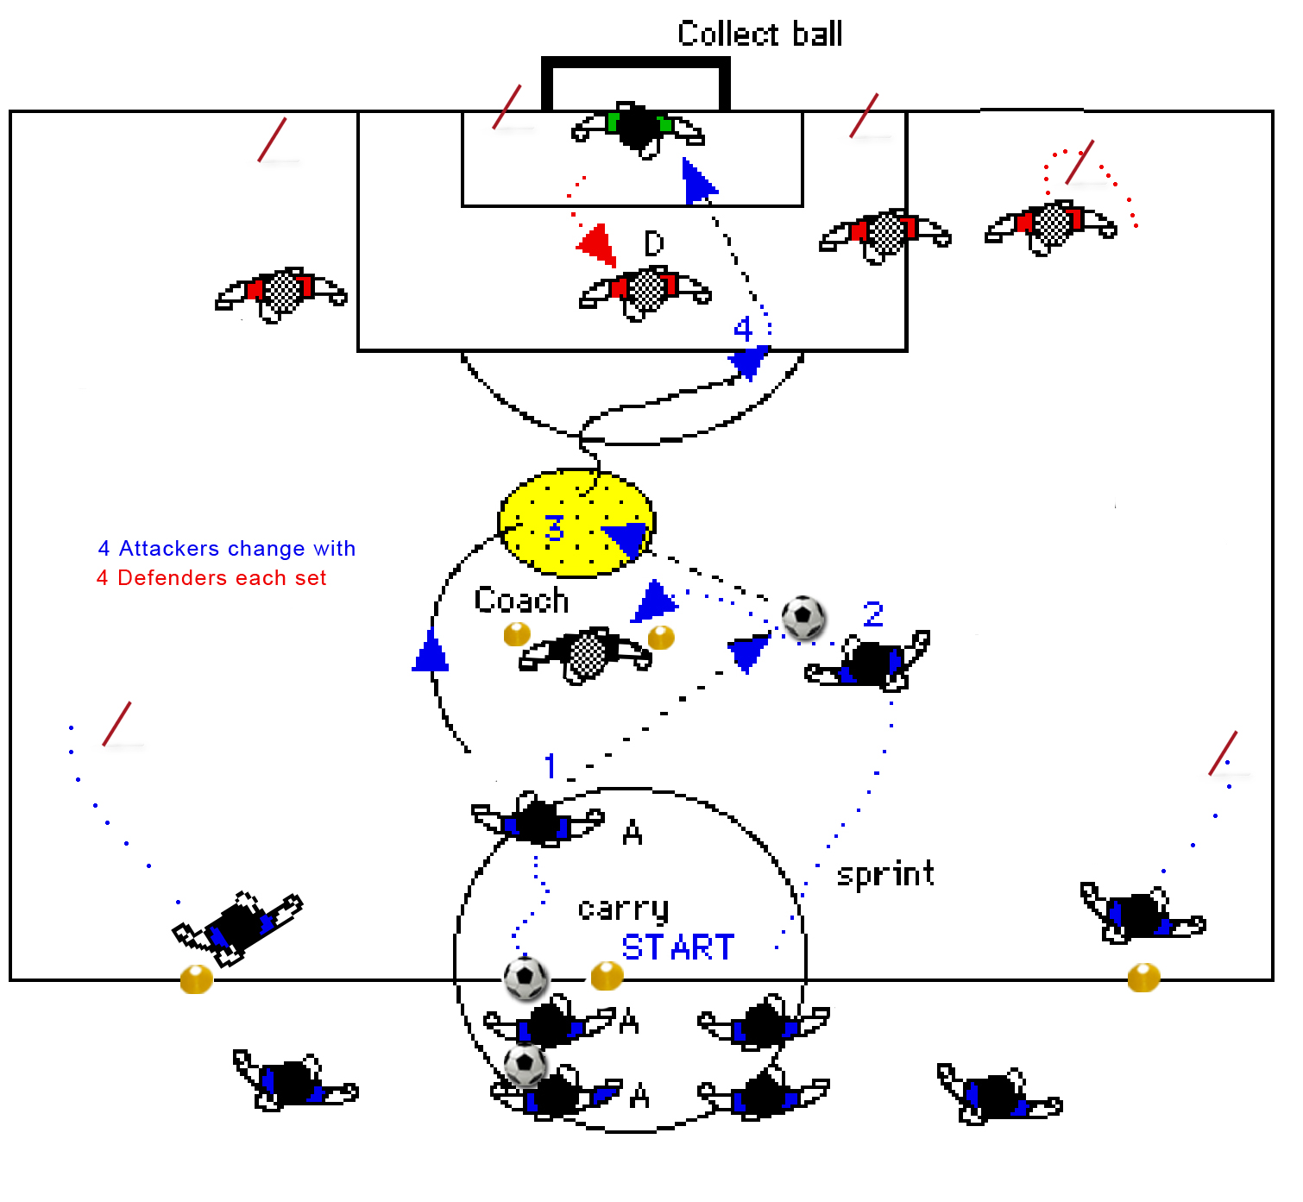
Wingers need to break wide each time then recover the ball and return to the halfway line

Goalkeeper normal saves

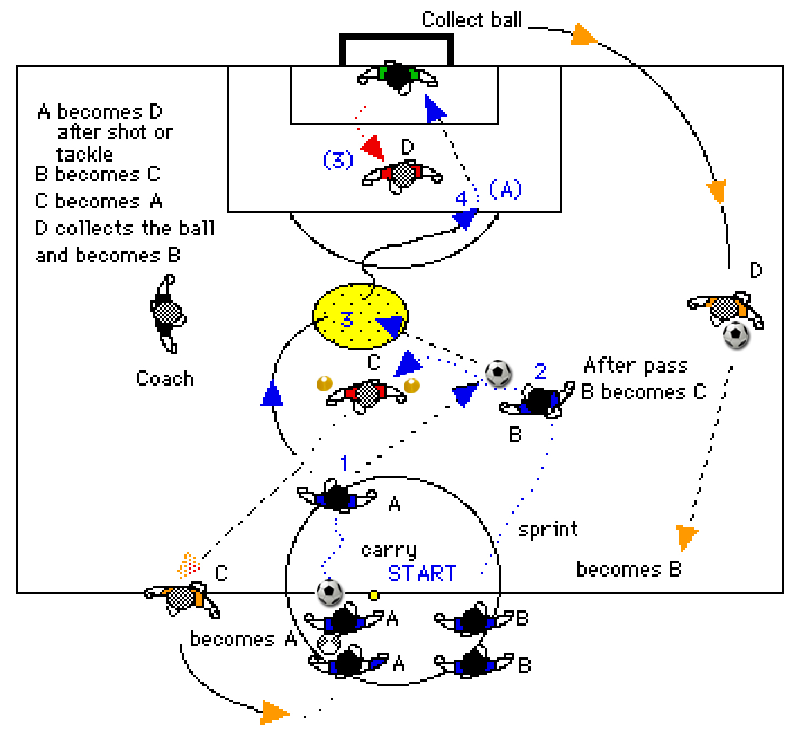
Roles: Defenders In the mini goal can come forwards only and MUST stay within the constraints of the goal. Player (D) starts from within the penalty area and defends the goal.

Attacking players Must make a good wall pass and get a shot on goal.

Coaching Points The running off the ball and the timing of the wall pass is the key. Watch and correct receiving and giving of passes use of the angle is important. Insist on passive defending in the mini goal. Encourage passing using outside and inside of boot. The central defender comes into play as a 1 v 1 to add reality and pressure to the receiver, however do not allow the defender to creep too far into play (restrict to penalty area).

Developments
i. Put an additional mini goal in line making players wall pass twice, the defender in the second mini goal is static and changes over occasionally.

ii. Keep the central defender in play for all moves if you wish to work the defenders role (sweeper) in the routine. Put a marker in the penalty area - the central defender touches the marker after each attack.

Phase ii: Add a winger or two wingers (depending on numbers) and bring in a back four. Start the routine with the wall pass then allow normal attacks. 3 v 4 or 4 v 4.

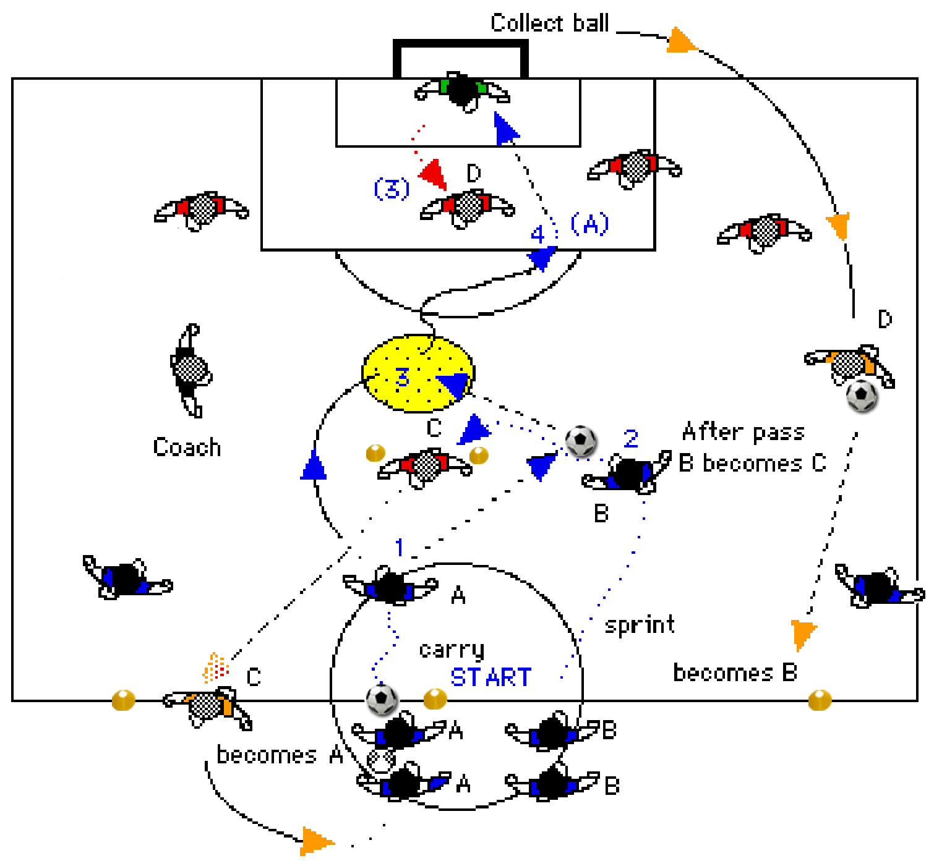
The next group of four or three (depending on numbers) then attacks whilst the first group of attackers is recovering to the half way line.
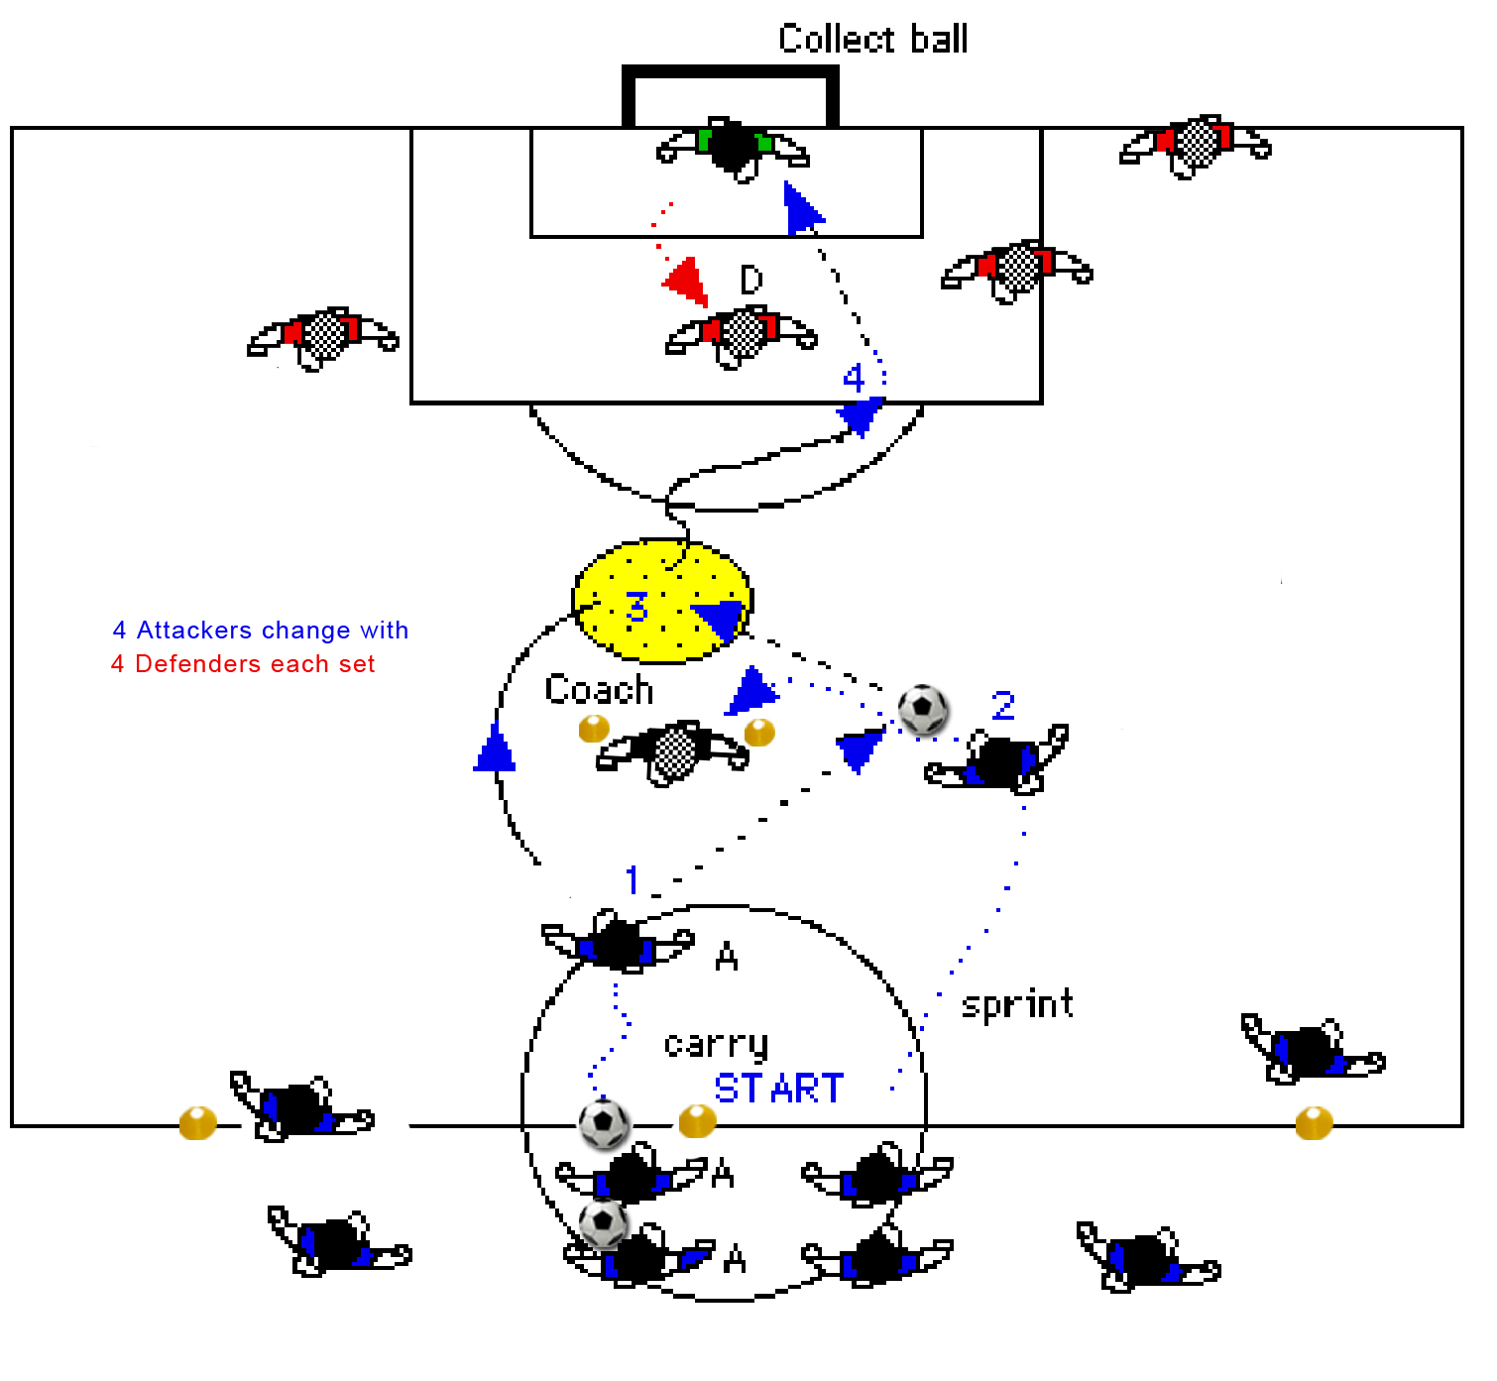
Use the grid to rotate roles, you (coach) or a spare player takes over Central Defender for wall pass and let other players change after each set, attackers become defenders. Defenders become attackers

